Budget Rent-a-Car
of British Columbia

Rate Uploading Tutorial (Geordy)

Version 1.00

Note: The information contained in this document is confidential and may not be disclosed to any parties outside of Budget Rent-a-Car of British Columbia Ltd. without written consent by one of its officers.
Copyright (C) 2010 Budget Rent-a-Car of British Columbia Ltd.
Entering Location Vehicle Rates

You can assign different rates for each vehicle class for each rental location for bcbudgettruck.com through the GIS Maintenance Tool, which can be accessed from C:\Program Files\GIS\GISMaintenance.adp. Let’s bring it up (See Figure 1).

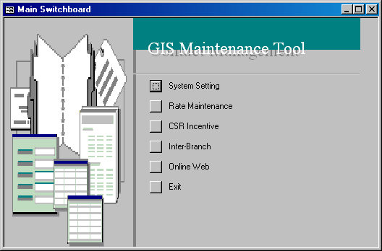
Figure 1: The main menu of the GIS Maintenance tool.

From the main menu of the GIS Maintenance tool, select Online Web. Note that you can only select Online Web and not the other menu items as they are only accessible by users with permissions.

Truck rental calculations are based on time blocks instead of days. The AM block refers to a morning rental, PM means an afternoon rental and OV stands for an overnight rental. Before we go into entering rates, you should learn the range for each time block. This can be done by clicking on the Truck Time Block button. The time blocks have already been setup prior to the GIS implemention for Geordy, as shown in Figure 2. The Block_Name, Block_Type and Block_Time columns indicate the drop off (DO) or pick up (PU) time for a block.

Let’s take a look at this line - Block_Name=AM; Block_Type=PU; Block_Time=08:00
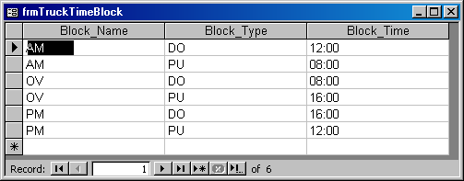
This means that the pick up time for the AM block is at 8AM. Each time block has to be defined by a pick up and drop off time. Therefore you will see 2 block types for each block name. From this table, we know that any rental between 8AM to 12PM fall within the AM block, any rental from 12PM to 4PM is in the PM block and anything after the PM and before the AM block will be in the remaining OV block.

Figure 2: The truck time blocks are defined in the TruckTimeBlock table.
Now that you are familiar with the time blocks, close the TruckTimeBlock window and select Online Truck Reservation Rate to start entering our rates. The Truck Reservation Rate screen will appear and you should see all your rates for bcbudgettruck.com from the start of Geordy’s GIS implementation up until now, as shown in Figure 3.

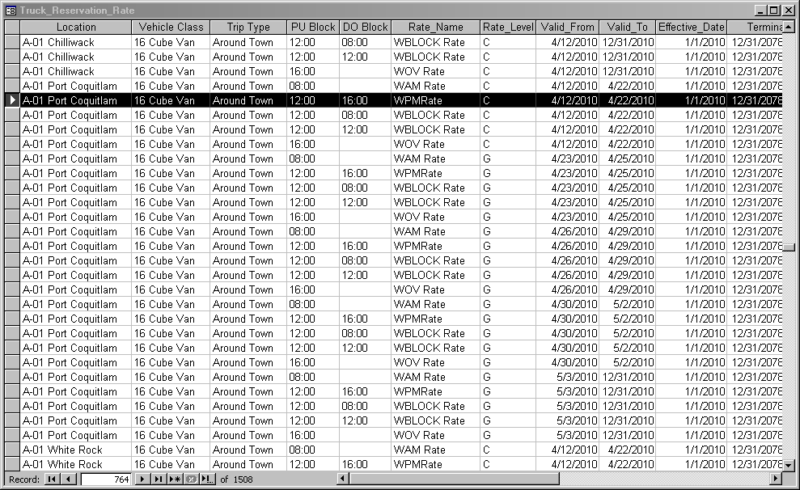
Figure 3: The Truck Reservation Rate screen.

To enter rates, you need to populate each column in the Truck Reservation Rate screen starting from the Location column. Populate the Vehicle Class, Trip Type, PU Block, DO Block, Rate Name, Rate_Level cells by selecting from their respective drop down lists. Trip Type refers to the ‘Around Town’, ‘Round Trip’ and ‘One Way’ trip types on bcbudgettruck.com.

NOTE
You can only enter ‘Around Town’ rates in the GIS Maintenance Tool. Any ‘Round Trip’ rates entered here WILL NOT be reflected in GIS.

The combination of PU Block and DO Block defines the pick up and drop off time for any reservation. Let’s take a look at the highlighted record in Figure 3 for an example. The PU Block and DO Block show 12:00 and 16:00 respectively, which means the rate WPMRate (Level G) will be applied to any 16 Cube Van reservation at PoCo that starts at 12PM and ends at 4PM.

Let’s have a look at another example using the record below the highlighted one. This time the PU Block and DO Block show 12:00 and 08:00, which basically means that the WBLOCK Rate (Level G) applies to any 16 Cube Van rental picking up from PoCo on 12PM on the date of rental and dropping off at 8AM the next day.
The Valid_From and Valid_To fields simply refer to the period of time in which the rate is valid for use. Enter ‘1/1/2010’ in Effective_Date and ‘12/31/2078’ in Termination_Date.

Now, entering rates row by row might prove to be a little tedious if you have to cover multiple vehicle classes at multiple locations. To make your life easier, you can prepare your rates in an Excel sheet first by duplicating and changing them. Then copy and paste them directly into the Truck Reservation Rate screen.

IMPORTANT
You can prepare your rates in any way you want in the Excel file but you must have all your rates in the exact order of Location, Trip Type, PU Block, DO Block, Rate_Name, Rate_Level, Valid_From, Valid_To, Effective_Date, Termination_Date when you copy and paste them into the maintenance tool.

As you enter your rates in Excel, be extra careful so that there are no additional spaces or characters in front of the values you enter. Have a look at the sample Excel sheet below.

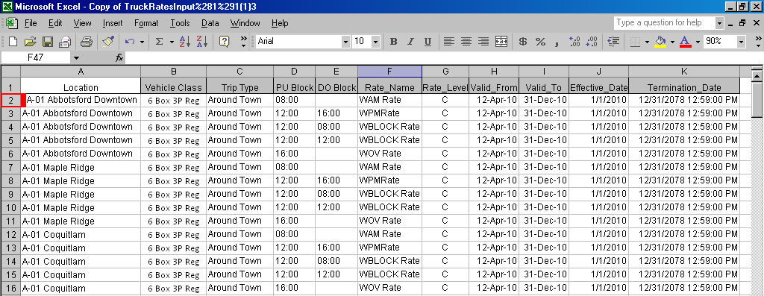
Figure 4: The first row has an extra space highlighted in red in the beginning.

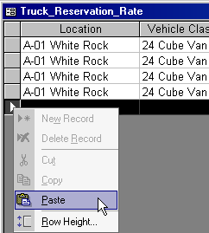
Notice that row 2 includes a blank space in front of the location and you are bound to get an error when you copy and paste the rows into the GIS Maintenance Tool. Let’s try it out.

Copy the rates from your Excel rate sheet, go back to the Truck Reservation Rate table and scroll down until you reach the end. You will know it’s the end when you see an empty row with an asterisk at the left-most cell. Right-click on the asterisk and click Paste (See Figure 5) to paste all the copied rows.

Figure 5: Copy and paste the selected
records to the GIS Maintenance Tool.

Once you hit Paste, an error message pops up telling you that the text you are about to paste is not in the list, as shown in Figure 6.

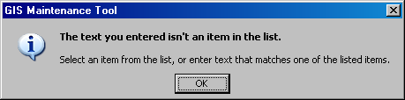
Figure 6: An error message appears because of the extra space in the Excel sheet.

‘..A-01 Abbotsford Downtown’ is not in the list because of the extra space at the beginning. The actual location is ‘A-01 Abbotsford Downtown’. Close that error window and another error message pops up (See Figure 7).

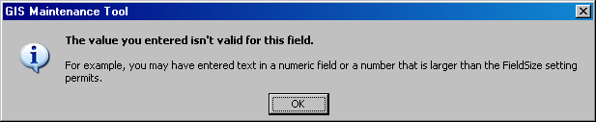
Figure 7: Another error message that appears because of the extra space in the Excel sheet.

Return to your Excel sheet, remove the extra spaces in row 2 and re-copy and paste the records again. This time the records are pasted successfully. Note that if you are copying and pasting too many records, the GIS Maintenance Tool will take a while to show all the pasted rows. Just be patient and leave the window as is when you are pasting too many records in one go.

That’s all there is to know about uploading rates.

